**EX NO: 9 Multiply matrices**

**Date :**

**AIM**

To write a python program to multiply matrices

Sample Input0 : [[1, 2], [1, 2]], [[1, 2], [1, 2]]

Sample Output0 : [[3, 6], [3, 6]]

Sample Input1 : [[1, 1], [1, 1]], [[1, 2, 1], [1, 2, 1]]

Sample Output1 : [2, 4, 2], [2, 4, 2]

Sample Input2 : [[1, 1], [1, 1]], [[1, 2], [1, 2], [1, 2]]

Sample Output2 : Cannot multiply the matrices. Incorrect dimensions.

**ALGORITHM**

X is M x N matrix

Y is N x P matrix

The resultant matrix of size M x P, multiplying X and Y,



where   
 i varies from 1 to M  
 j varies from 1 to P

**FLOWCHART**

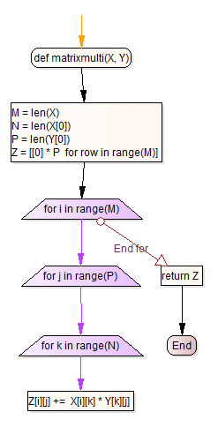

end for  
(j loop)

end for  
(k loop)

**PRE-LAB QUESTIONS**

1. How to initialize a matrix (5 by 5) so that all its entries are equal to the number 10? What is the one line code for this?
2. Write a program to test whether the given matrix is a square matrix or not.
3. Write a program to test whether the given two matrices (say a and b), the matrix product operation a * b is possible or not.

**SOURCE CODE**

def matrixmulti(X, Y):

# X dimension is M x N

# Y dimension is N x P

M = len(X)

N = len(X[0])

P = len(Y[0])

# resultant matrix dimension is M x P

Z = [[0] * P for row in range(M)]

if N != len(Y):

print ("Incorrect dimensions.")

return

for i in range(M):

for j in range(P):

for k in range(N):

Z[i][j] += X[i][k] * Y[k][j]

return Z

**OUTPUT**

**RESULT**

Thus the python program for multiplying two matrices was executed and verified successfully.

**POST-LAB QUESTIONS**

Consider a two-dimensional matrix containing integer entries in which all rows and all columns are sorted in ascending order. For example:

1 12 43 87

9 25 47 88

17 38 48 92

45 49 74 95

Your task is to write a program that takes a matrix as describe above, and a target integer, and determines if the target integer is present in the matrix.